# NAME:

# S/O: ROLL#: 2K20/ITE/

# SUBJECT: MOBILE APPLICATION DEVELOPMENT

# SUBMITTED TO: DR ZEESHAN

**TASK 1-3**

# TASK 1

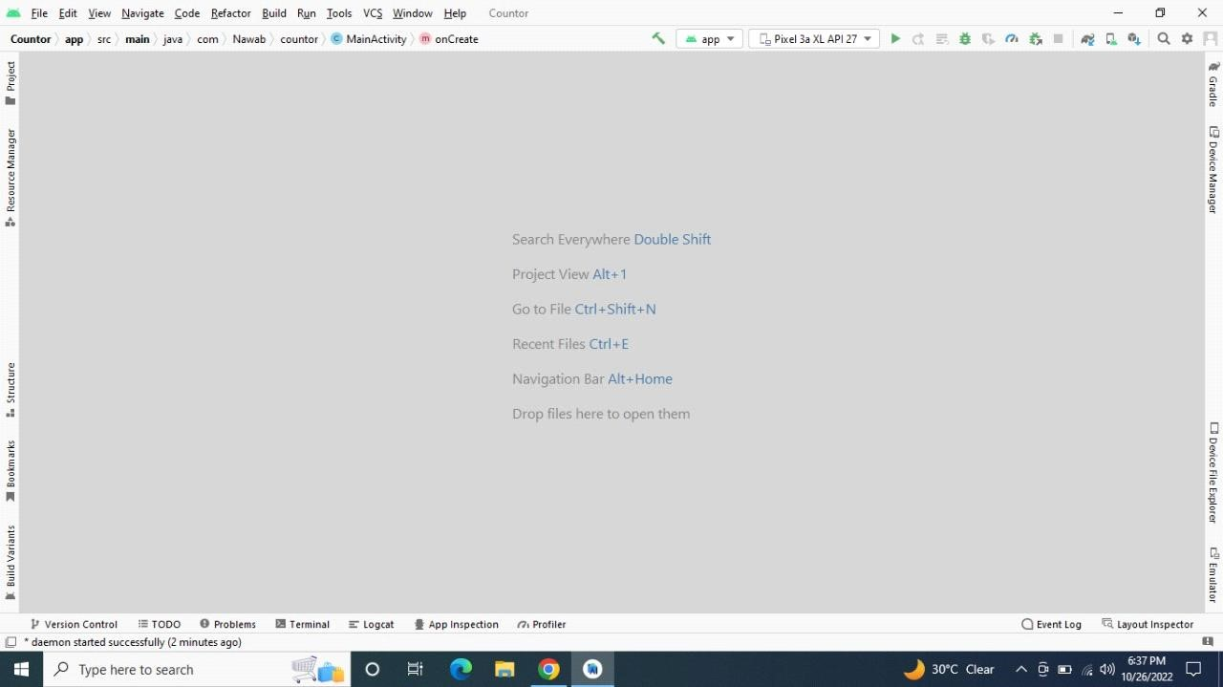

# TASK

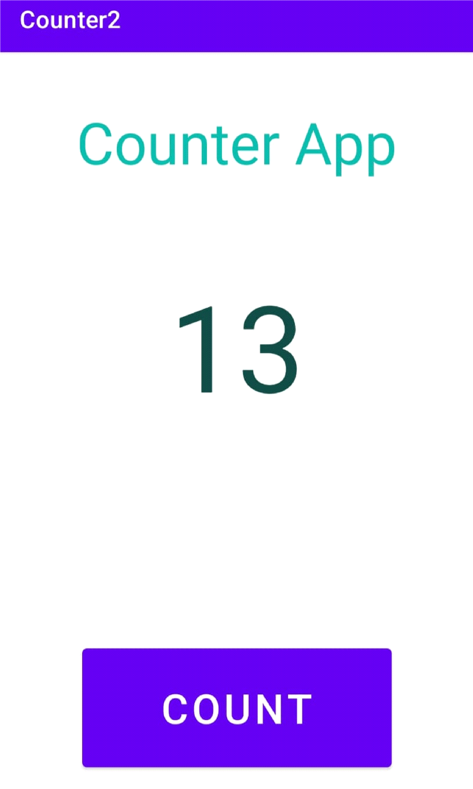

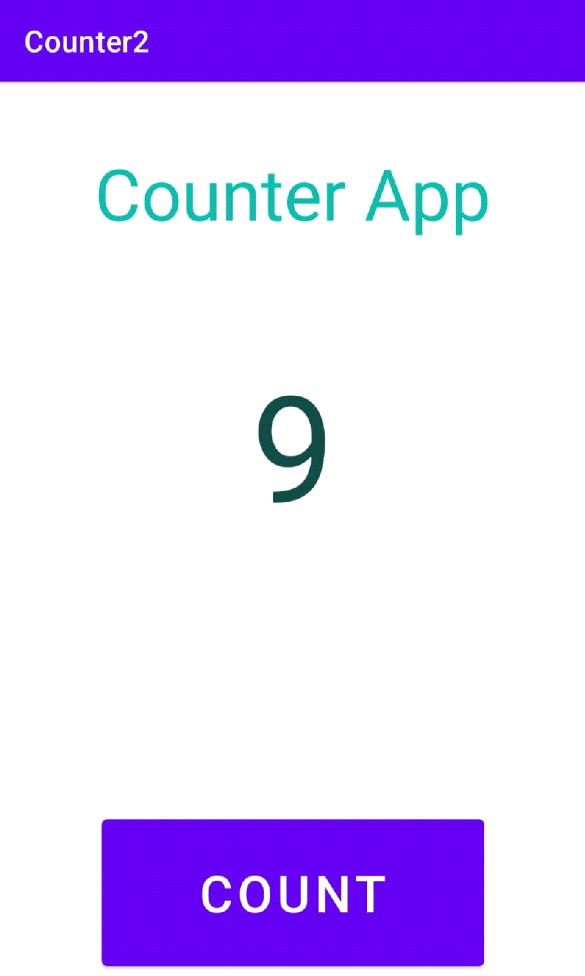

**Code:**

**package com.example.counter;**

**import androidx.appcompat.app.AppCompatActivity;**

**import android.os.Bundle;**

**import android.view.View;**

**import android.widget.Button;**

**public class MainActivity extends AppCompatActivity {**

**int counter;**

**@Override**

**protected void onCreate(Bundle savedInstanceState) {**

**super.onCreate(savedInstanceState);**

**setContentView(R.layout.activity_main);**

**TextView txtCount = findViewById(R.id.txtCounter);**

**Button btnCount = findViewById(R.id.btnCounter);**

**Button btnReset = findViewById(R.id.btnReset);**

**counter=0;**

**btnCount.setOnClickListener(new View.OnClickListener() {**

**@Override**

**public void onClick(View view) {**

**counter++;**

**txtCount.setText(""+counter);**

**}**

**});**

**btnReset.setOnClickListener(new View.OnClickListener() {**

**@Override**

**public void onClick(View view) {**

**counter=0;**

**txtCount.setText(""+counter);**

**}**

**});**

**}**

**}**

# TASK 3

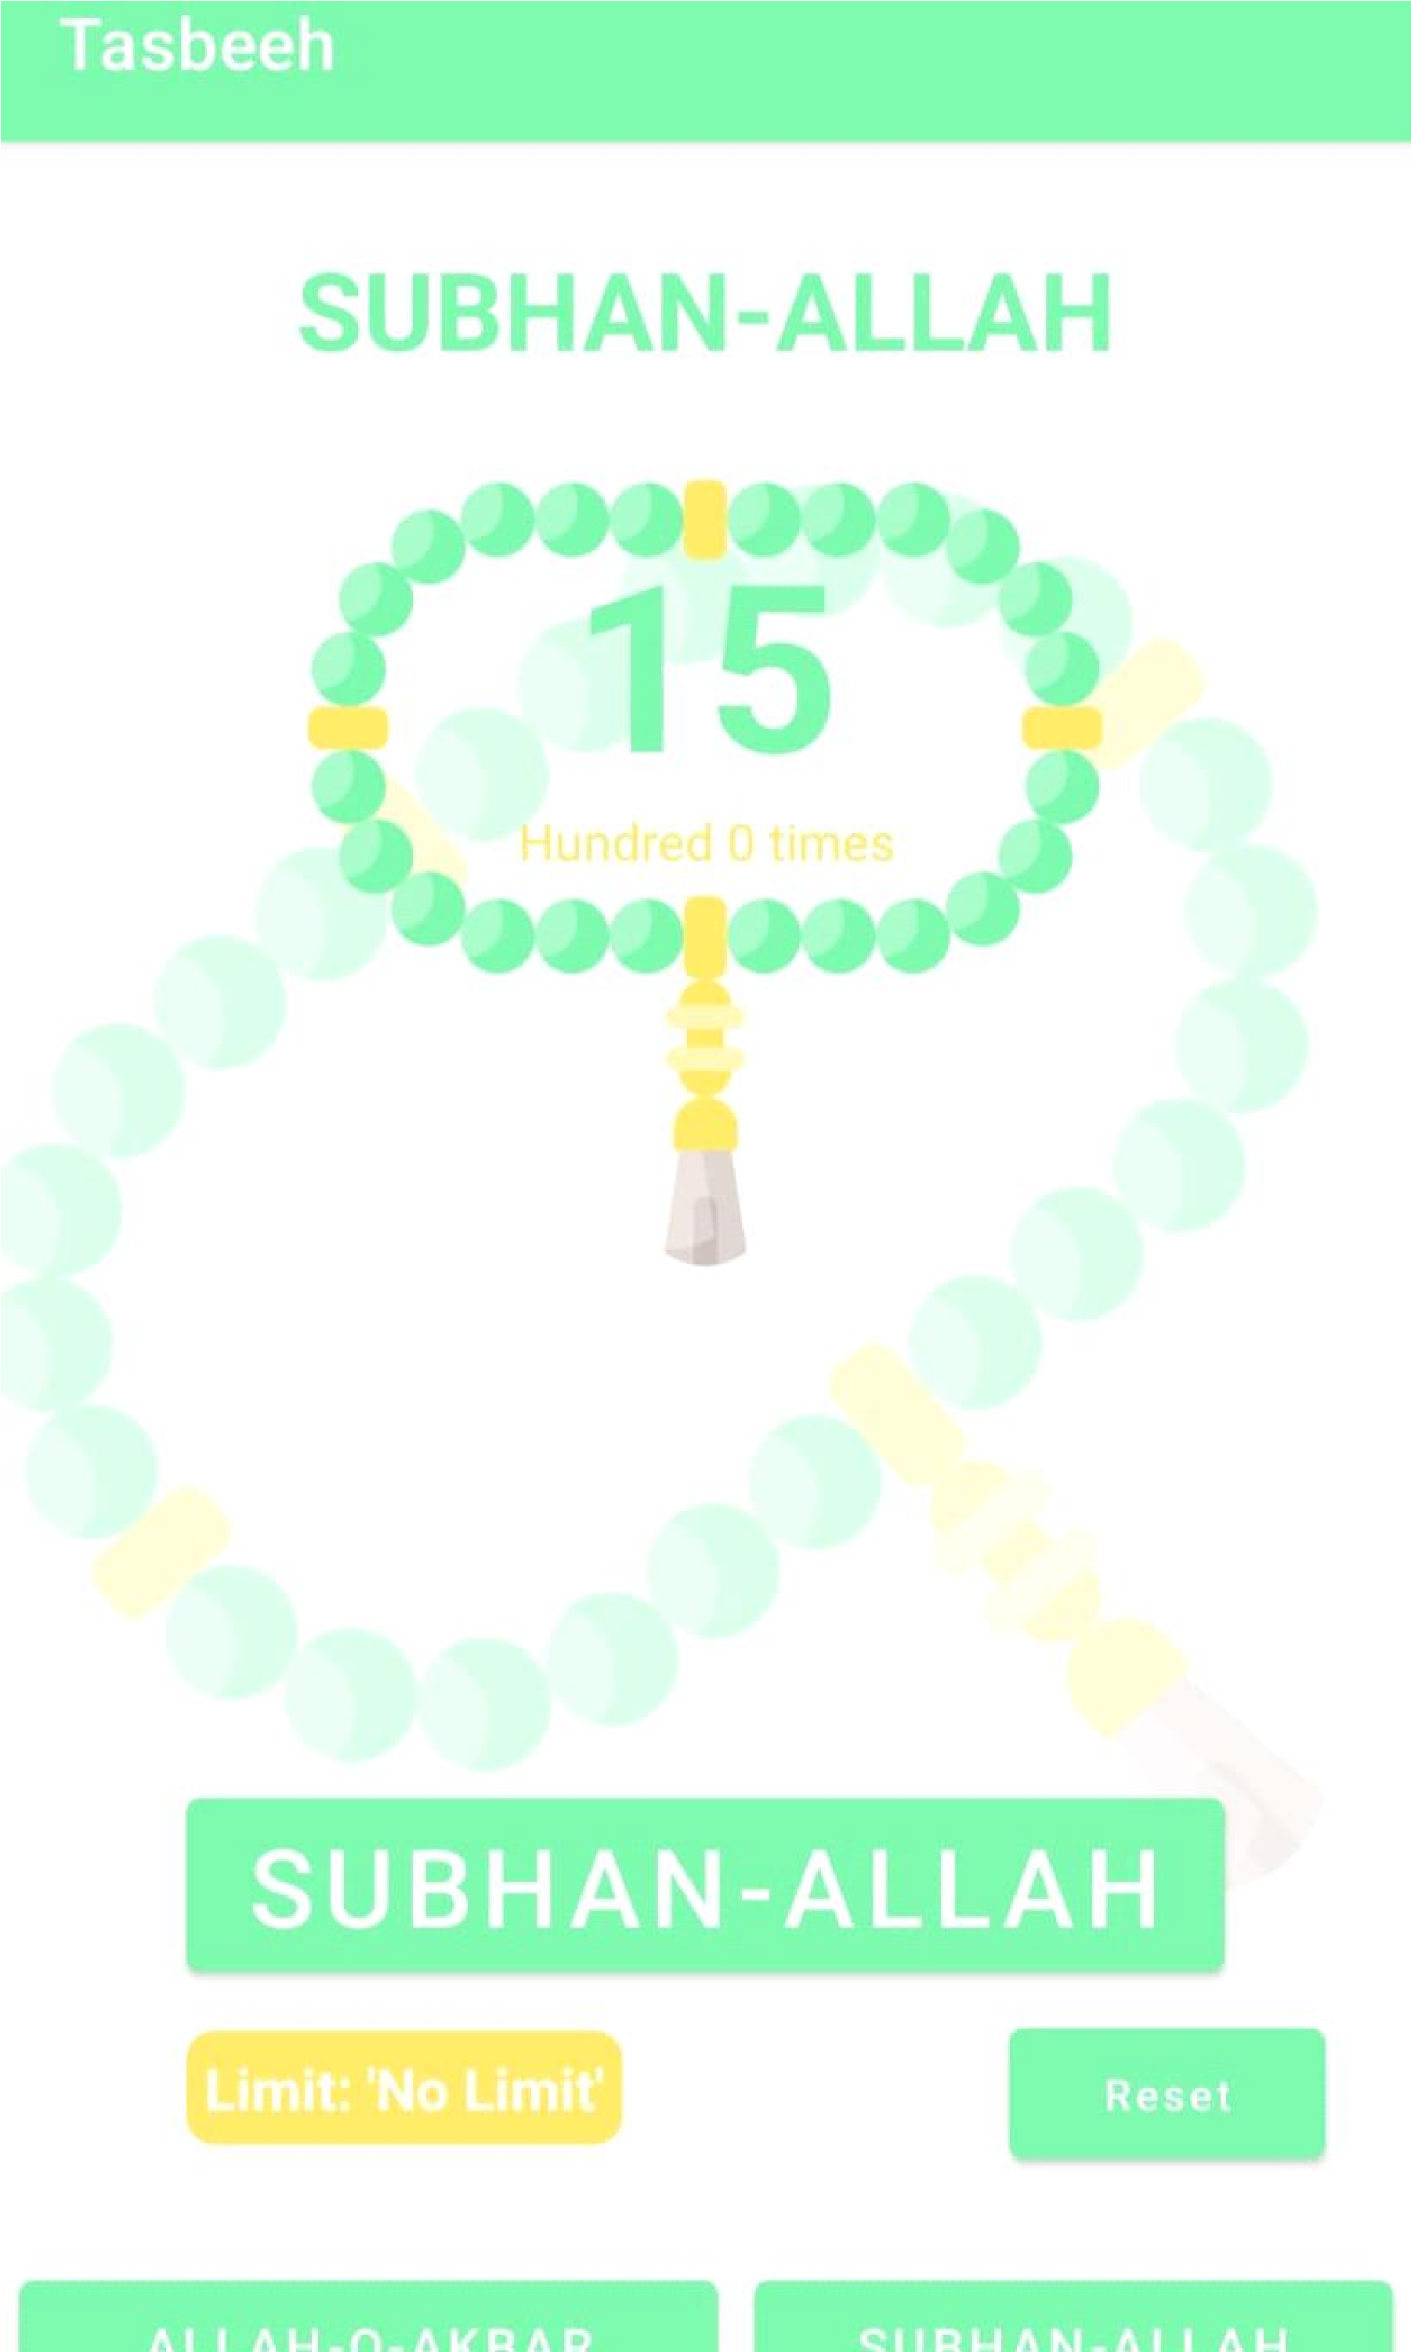

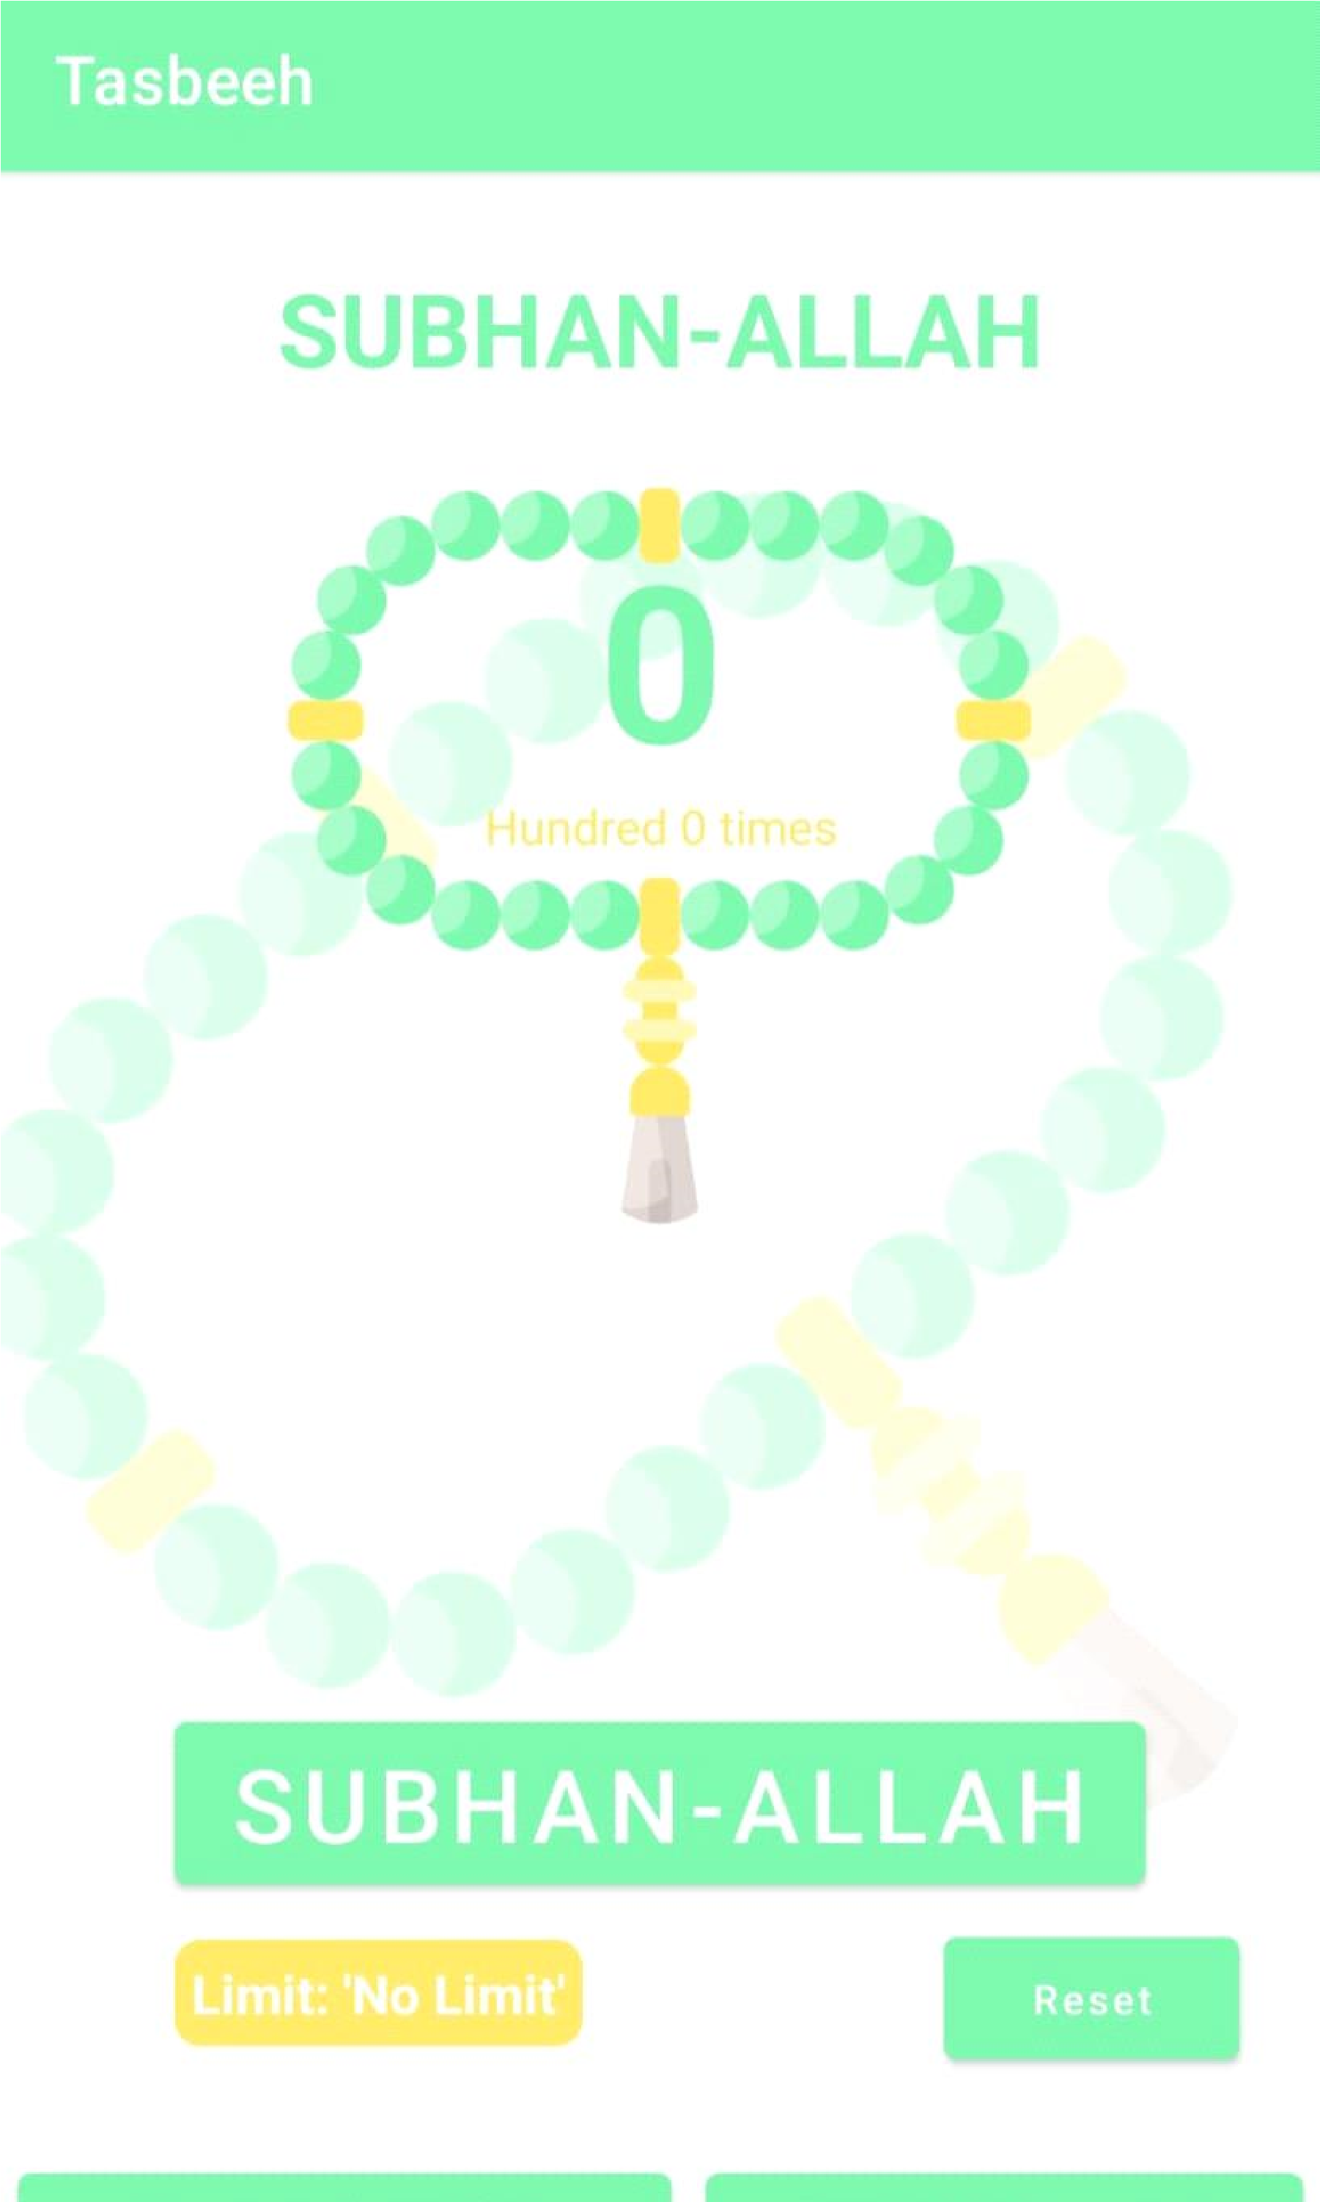

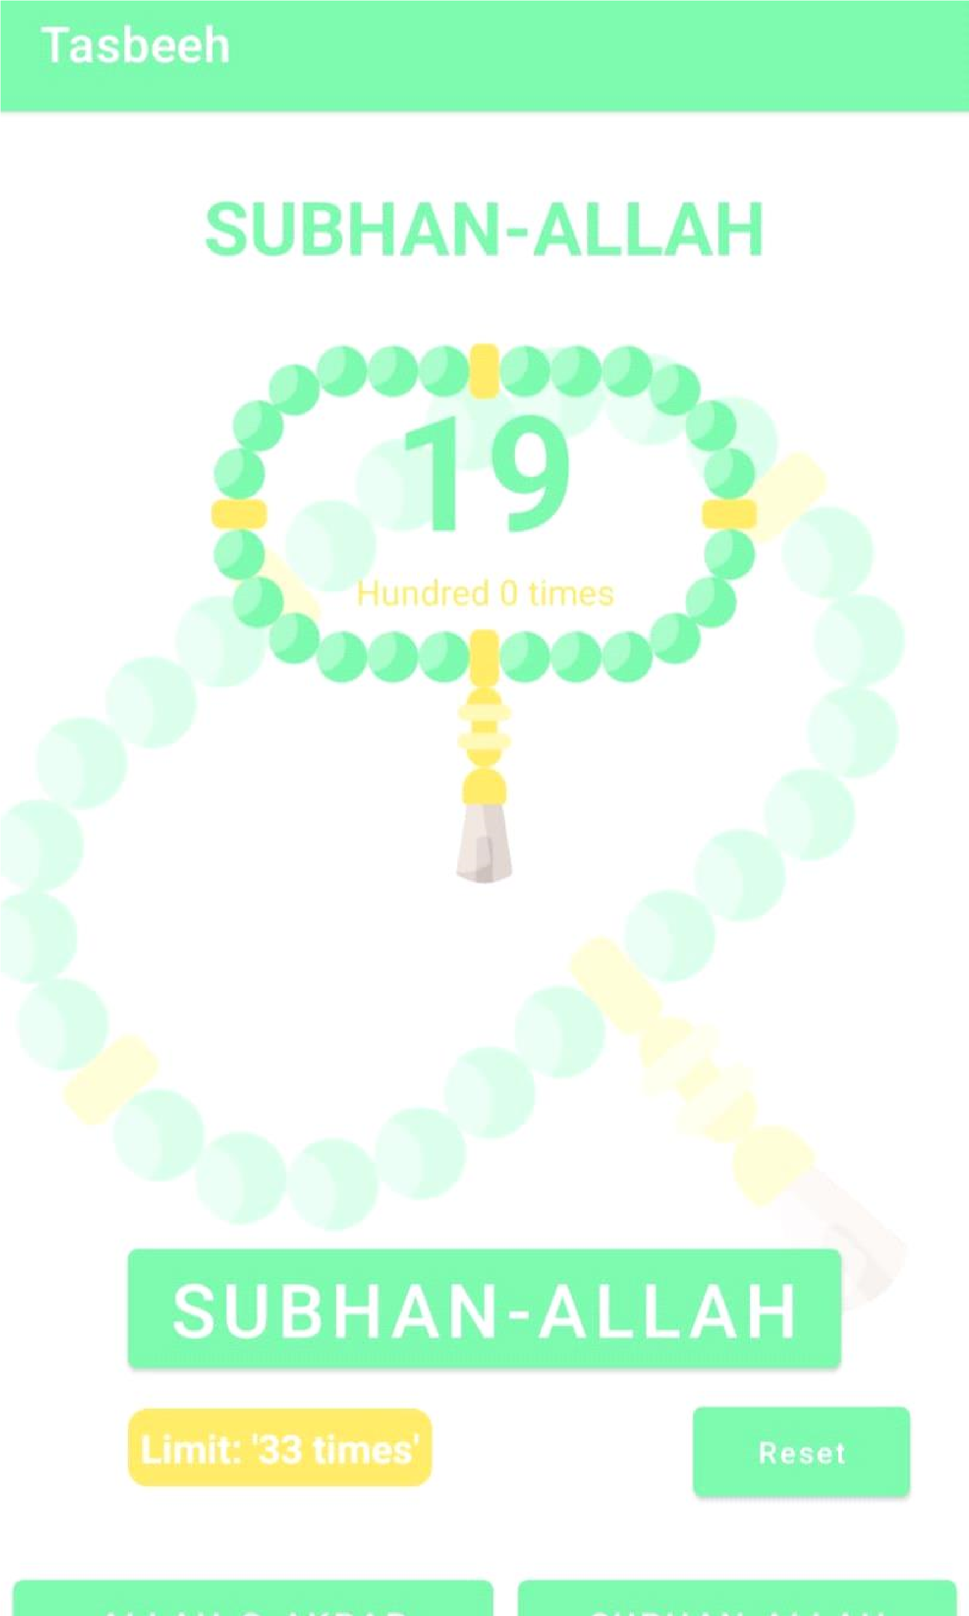

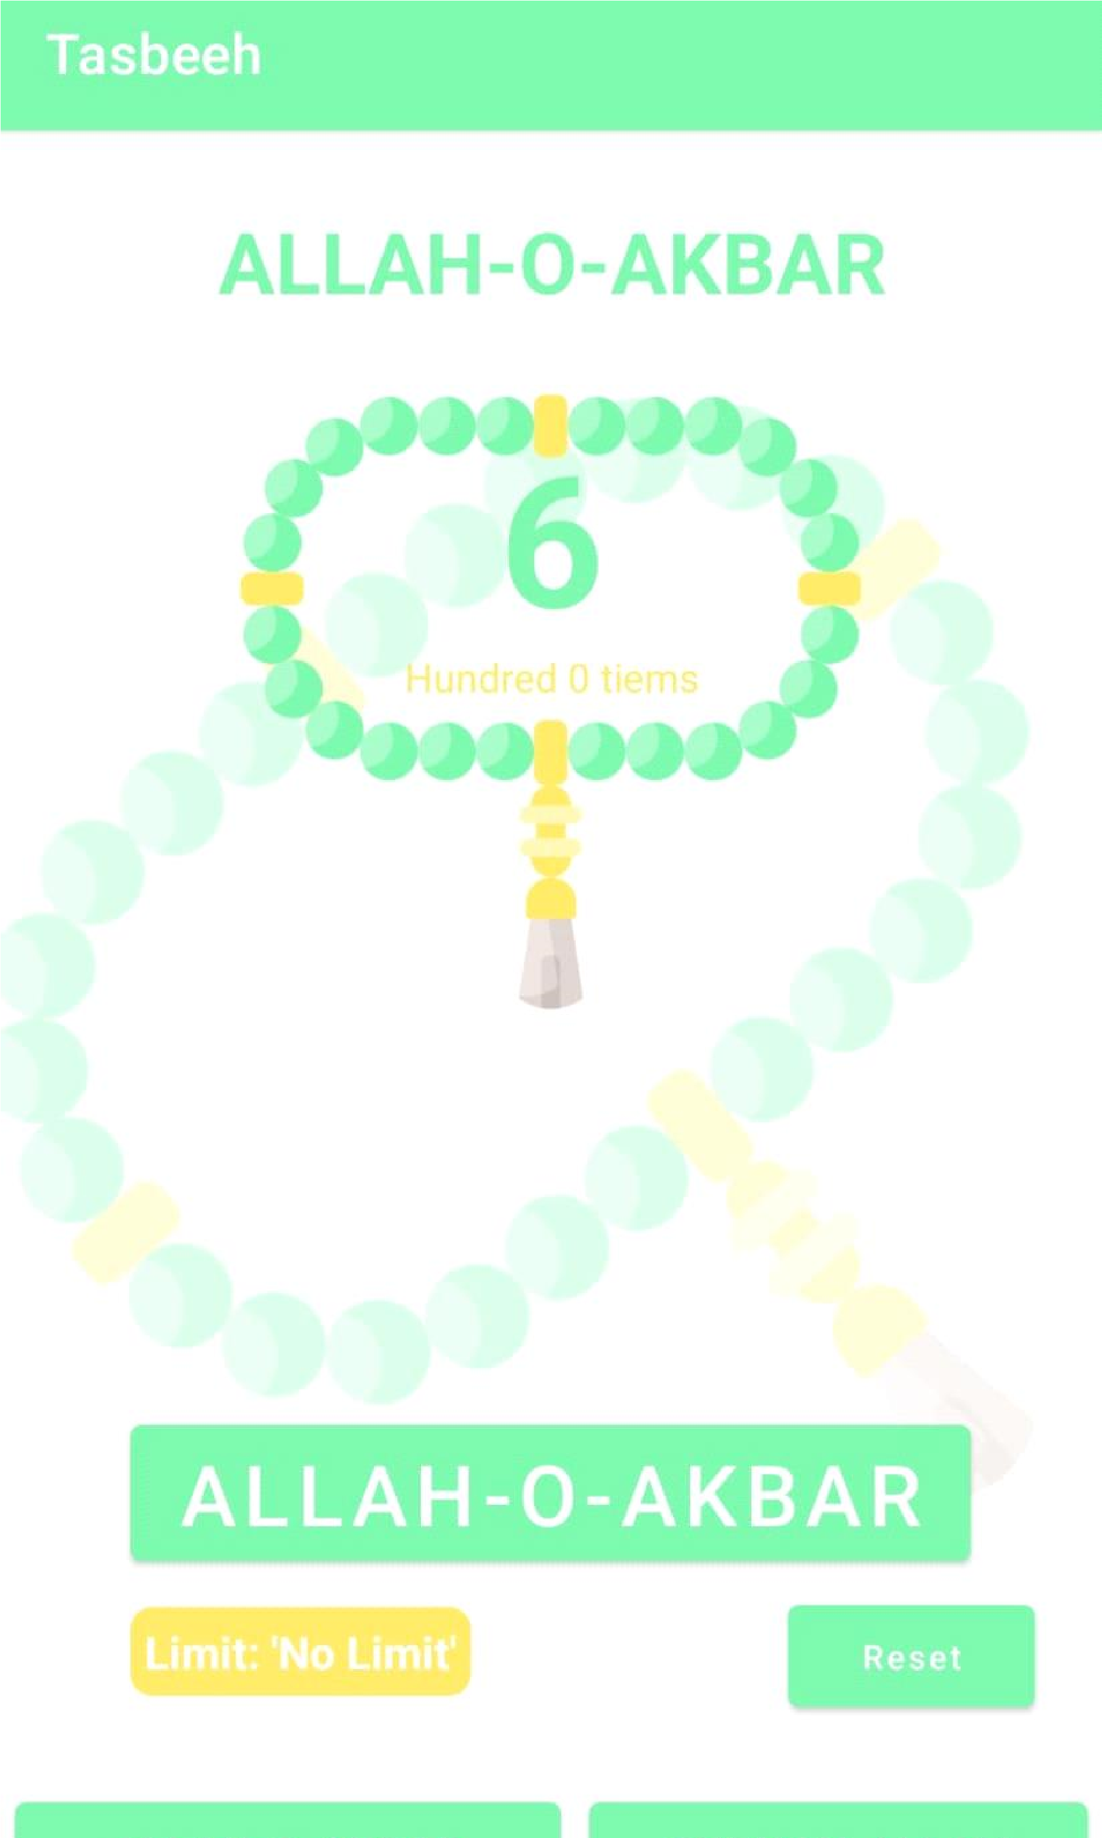

**Code:**

**package com.example.counter;**

**import androidx.appcompat.app.AppCompatActivity;**

**import android.os.Bundle;**

**import android.view.View;**

**import android.widget.Button;**

**import android.widget.TextView;**

**public class MainActivity extends AppCompatActivity {**

**int counter;**

**int limit;**

**@Override**

**protected void onCreate(Bundle savedInstanceState) {**

**Page**

**5 of 14**

**super.onCreate(savedInstanceState);**

**setContentView(R.layout.activity_main);**

**TextView txtCount = findViewById(R.id.txtCounter);**

**TextView btnCount = findViewById(R.id.btnTasbeeh);**

**Button btn33 = findViewById(R.id.btn33);**

**Button btn100 = findViewById(R.id.btn100);**

**Button btnReset = findViewById(R.id.btnReset);**

**Button btnnoLimit = findViewById(R.id.btnNolimit);**

**counter=0;**

**limit=0;**

**btnCount.setOnClickListener(new View.OnClickListener() {**

**@Override**

**public void onClick(View v) {**

**//counter++;**

**if(limit==33 && counter<33){**

**counter++;**

**}**

**else if(limit==100 && counter<100){**

**counter++;**

**}**

**else if(limit==0){**

**counter++;**

**}**

**txtCount.setText(""+counter);**

**}**

**});**

**Malik Muhammad Huzaifa (2K20/ITE/65)**

**btnReset.setOnClickListener(new View.OnClickListener() {**

**@Override**

**public void onClick(View v) {**

**counter=0;**

**txtCount.setText(""+counter);**

**}**

**});**

**btn33.setOnClickListener(new View.OnClickListener() {**

**@Override**

**public void onClick(View v) {**

**limit=33;**

**}**

**});**

**btn100.setOnClickListener(new View.OnClickListener() {**

**@Override**

**public void onClick(View v) {**

**limit=100;**

**}**

**});**

**btnnoLimit.setOnClickListener(new View.OnClickListener()**

**{**

**@Override**

**public void onClick(View v) {**

**limit=0;**

**Page 6 of 14**

**}**

**});**

**}**

**}**